**Commodore Port Breakout: IEEE-488 Output Rev. 0**

**Module Description**

# Introduction

This assembly provides the edge connector for a Commodore PET IEEE-488 Port. The purpose is connecting it to the 2x12 Breakout board via a ribbon cable.

Every pin of the edge connector is connected to a pin of the (2x13p) box connector/pin header. The “GND” pins of the IEEE-488 port are all connected on this board.

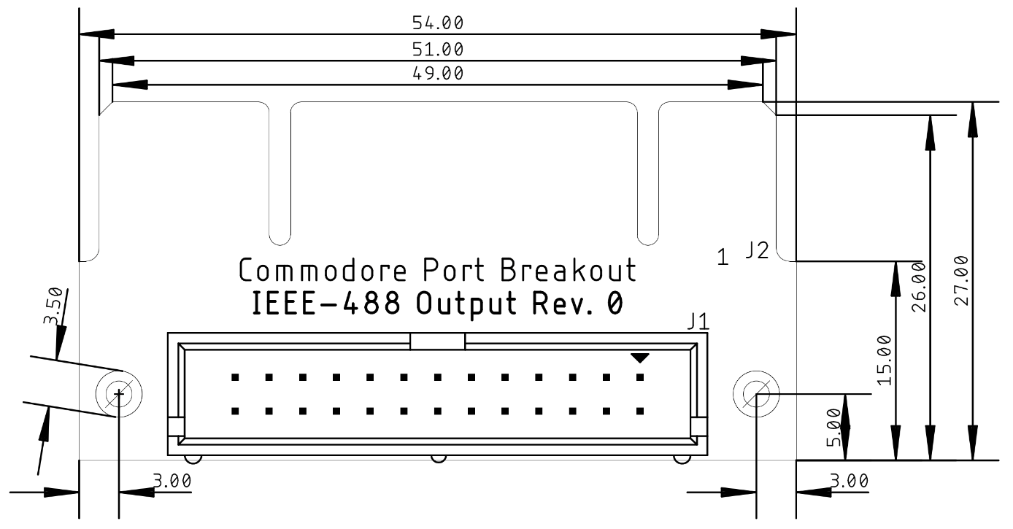

Figure 1: Dimensions of the PCB

# Connector Pinout

J1: 2x13 box connector/pin header 2.54mm pitch.

J2: board edge connector (a structure on the PCB).

|  |  |  |
| --- | --- | --- |
| J1 | IEEE-488 | J2 |
| 1 | DIO1 | 1 |
| 3 | DIO2 | 2 |
| 5 | DIO3 | 3 |
| 7 | DIO3 | 4 |
| 9 | EOI | 5 |
| 11 | DAV | 6 |
| 13 | NRFD | 7 |
| 15 | NDAC | 8 |
| 17 | IFC | 9 |
| 19 | SQR | 10 |
| 21 | ATN | 11 |
| 23, 25 | GND | 12 |
| 2 | DIO5 | A |
| 4 | DIO6 | B |
| 6 | DIO7 | C |
| 8 | DIO8 | D |
| 10 | REN | E |
| 12 | GND | F |
| 14 | GND | H |
| 16 | GND | J |
| 18 | GND | K |
| 20 | GND | L |
| 22 | GND | M |
| 24, 26 | GND | N |

# Revision History

## Rev. 0

* Prototype